CSUF College of Humanities & Social Sciences
Inter-Club Council Meeting
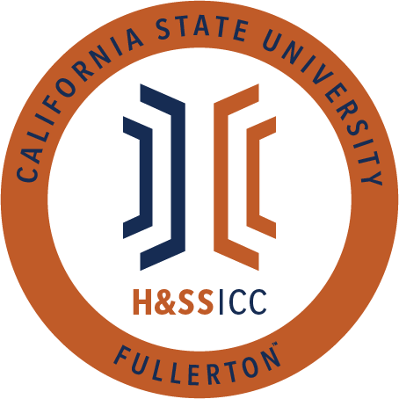

December 6th, 2019 11:00 A.M.
TSU Legislative Chambers

Meeting called by:
Jacqueline Montero, Chair

Type of meeting:
Regular

Attendees:
Council Representatives, Executive Officers, General Public
Absent: ETA, Geography, PAGSOCA, PSSA.

Agenda Topics:

- Call to Order / Roll Call 11:06 am
- Approval of Minutes
  - Acacia approves, CJSA seconds.
- Approval of Agenda
  - Chair moves to remove line item A of New Business, Abled Advocators seconds.
  - CJSA approves, PAT seconds.
- Public Speakers
- Budget
  - 8074 – Contracts, Fees and Rentals: $ 14,663.75
  - 8077 – Travel: $ 4,912.37
- Reports
- Chair – Jacqueline Montero
  - Thanks for those who showed up to bylaw revision committee. We will be continuing next semester because there are a lot of changes. Adding to the agenda as is will take too much time in our council meetings. We can have more special meetings next semester, with regularity.
  - Next meeting is the last meeting of the semester.
Executive board is providing main course and the sign up sheet will be going out later.
    - January 24th is our first meeting but it is unofficial.
      - Meetings will be at the same day, times, and location.
    - Registration packets are due January 31st. Jacky will send out the registration information by next week.
      - Every organization has to register every semester so we know who is returning and the reps will be.
      - Only new organizations have to present but we could take a little bit of time to reintroduce their organizations.
      - We recommend having your ICC reps for next semester picked out and prepared by the end of this semester
- Vice Chair / Treasurer – Ginny Oshiro
  - December 12th is a hard deadline to turn in receipts to get reimbursements before the break otherwise will be processed after January 6th. Please communicate that you dropped off receipts so we know to look for them and process them.
  - There will be a Traveling with ASI Funds Training that is open to council reps
    - It will be happening over the break on January 16, 2020 3 - 4 PM and January 17th from 10:30 AM and 11:30 AM. This is not mandatory but could be helpful.
  - Gabi sent an email to organizations who signed up for the student showcase. Please check for that email and respond.
- Director of Administration – Gabriella Cuna
- Director of Public Relations – Leslie Rodriguez
- Social Justice Facilitator – Valarie Segovia
- Advisor – Dr. Connie Moreno Yamashiro, Assistant Dean
  - Wrapping up the semester and received a report that a couple hundred students haven't signed up for courses next semester. If you know any of these students who aren’t sure they’ll be returning next semester please direct them to Connie because HSS wants to support these students.
  - Dean Fontaine had to cancel but will come in early spring to get feedback on HSS building.
  - SLL has a deadline of December 20th to sign up for Discoverfest. It will be on Wednesday 1/29 and Thursday 1/30 from 11 AM - 2 PM. They only take for the first 200 to register. If you have signed yet signed up for Discoverfest, please sign up to recruit new members. Membership is critical to orgs. All details can be found on Titanlink.
  - Funds from GI2025
    - Schools supplies available next week in GH 211 B. Scantrons, pens, pencils, highlighters, etc. Come next week or the week of finals until supplies last - you can take as you need.
    - We do ask that you fill out a half sheet and sign into the success center at the front desk.
  - Will be leaving today at 12:15 for transfer orientation.
- Graduate Assistant – Miguel Quirarte
  - McNair Prep Academy for 2022 graduates. Flyer was passed.
  - Panetta Institute Internship, DC in U.S Congress. Flyer was passed.
- ASI Liaisons – Maria Linares and Melanie Therrien
- H&SS Week Committees
- Old Business
- New Business
  - Dean Fontaine – Time Certain 12:00 pm
  - Rebound Scholars would like to request $500.00 from Line Item 8074 for their Healing Circle event, which takes place December 11th, from 2-4 pm in Ontiveros BC. Funds will be used for Honoria for Jeremy Michael Vasquez.
    - Rebound Scholars moves to open, Abled Advocators seconds.
    - Motion passes.
  - Alpha Phi Sigma would like to request $91.57 from Line item 8074 for their Chapter Meeting on December 11th, from 5:00pm- 7:00pm in H-511. Funds will be used to provide sandwiches, chips, veggies, granola bars, and capri-suns for all who attend.
    - APS moves to open, CJSA seconds.
    - Motion passes.
  - ASSA would like to request $2,096.82 from Line Item 8074 for their American Papers, their annual journal that publishes the best submitted essays, critical reviews, and research papers written by CSUF students of any major for an American Studies course. Funds will be used to print 150 copies of the American Papers.
    - ASSA motions to open, LSPA seconds.
    - This journal gets published every spring since the 1980s so ASSA is hopeful and excited to continue the tradition. This will be the 38th volume.
    - If you are approved will the books be sold?
      - No the books are free and will be available in the ASSA lounge.
    - Motion passes
  - TESOL would like to request $96.23 from Line Item 8074 for their Movie Night which will take place on December 6th, from 5pm-8pm. Funds will be used to provide pizza and to pay for the movie rental.
    - ASA opens, ASSA seconds.
    - LSPA rep proposed on behalf and yields to TESOL.
    - Motion passes.
- Next Week’s Agenda
  - SIRE would like to be added to Line Item 8077
  - SIRE would like to be added to Line Item 8074
- Announcements
  - There is a feminist symposium in TSU Bradford B today until 5pm. Next Monday ASSA is screening the Times of Harvey Milk in LH 207. Both of these announcements will be posted in GroupMe
  - DSS is hosting a goodbye/farewell at 1 PM in GH 148 AB.
  - Rebound Scholars showed pictures for the conference he was funded to go to - presented in front of 450 people. Grateful for the opportunity to travel - thank you to ICC
  - We had the bylaw revision this morning but will stay after to answer any questions.
  - APS currently holding a drive for Orangewood - will hold drive until December 16th. Drop off in Humanities 112.
  - LASSA Thursday December 12th in H 226, will have speaker and showing a documentary. Details will be posted in GroupMe.
  - SAAAS also showing movies and having pizza next week. Details will be posted in GroupMe
  - AAEE asks about holiday mart - will be collecting through next week on the 13th.
- Adjournment - 11:57 AM

