CSUF College of Humanities & Social Sciences
Inter-Club Council Meeting
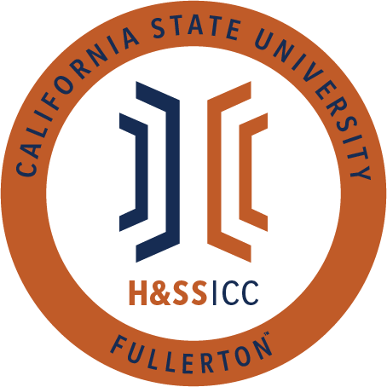

December 4, 2020 11:00 A.M.
Zoom

Meeting called by:
Halima Baba, Chair

Type of meeting:
Regular

Attendees:
Council Representatives, Executive Officers, General Public

Agenda Topics:

- Call to Order / Roll Call-11:00 AM
  - Rebound Scholars and SAAAS are marked as absent from the meeting
- Approval of Minutes
  - CJSA motions to approve the minutes and AKD seconds
- Approval of Agenda
  - ASA motions to approve the agenda and AKD seconds
- Public Speakers
This is a time where members of the public may address the humanities and social sciences council on any item appearing on this agenda or matters impacting students.
Time Certain 11:30AM to 11:50AM – Dean Fontaine and Associate Dean Stern
5. Budget
  - 8074 – Contracts, Fees and Rentals: $32,610.00
  - 8077 – Travel: $19,181.00
6. Reports
- Chair – Halima Baba
  - To be a part of HSS ICC, organizations need to register every semester. Re-registration is coming up, and it will be due on January 29, 2021. Halima will send out an email with a checklist at the end of this meeting. Please be mindful of the deadline and start ASAP.
- Vice-Chair / Treasurer – Lila Marlene Rodriguez
  - All the people who have submitted gift card forms/emails about reimbursement shouldn't worry since the paperwork is currently being processed. Expect to receive a reimbursement within the next few business days.
- Director of Administration – Savannah Arana
  - Nothing to report, so I will yield
- Director of Public Relations – Jennifer López
  - J-Lo sent something on GroupMe in regards to Dean Fontaine and Associate Dean Stern coming today. We will be using https://www.menti.com/ to ask anonymous questions to our esteemed guests.
- Social Justice Facilitator – Tonya Somesh
  - Nothing to report, so I will yield
- Advisor – Dr. Connie Moreno Yamashiro, Assistant Dean
  - Friday, January 29, 2021, is the first unofficial meeting for the Spring semester. Friday, February 5, 2021, is the first official meeting. Same time and Zoom link.
  - Re-Registration packets due by 5 PM on January 29
  - Next Friday, December 11, 2020, is the final HSS ICC meeting for this semester.
  - CR/NC option: http://coronavirus.fullerton.edu/academic-year-2020-21-credit-no-credit-grading-basis-for-csuf-students/
  - Next week the Student Success Center will be holding two workshops for students to learn more about the CR/NC option. Links to sign up are here: December 8th https://fullerton.zoom.us/meeting/register/tZ0ldOmrrj8uHtfwHHiWSJCMxrx6rpU8WjJ9 December 11th https://fullerton.zoom.us/meeting/register/tZEqce2urzktH9ag9lpZ64ZwHursC-NzRrRd
  - SLL newsletter – Discoverfest: https://fullerton.campuslabs.com/engage/news/206809
- Graduate Assistant – Shanice Watson
  - We are updating the HSS Week website so students will be able to find the most up to date information.
- ASI Liaisons – Erick Murillo and Maria Linares
  - Provost Carolyn Thomas, student leaders, and I discussed the possibility of students shooting short videos about a transformational learning experience they had this semester. If any of you are interested, could you please email me? I would need to send your email address to the provost’s office. If you have had a positive experience this semester, please message me. The provost thinks these student testimonials may help faculty improve their virtual classroom structure and reassess their lecture and grading practices. My email is asboardchair@fullerton.edu
  - ASI has a finals program, so there will be different events hosted during finals Monday through Friday. Links and fliers will be posted on GroupMe.
7. HSS Week Committees (April 5th- April 9th, 2021)
8. Old Business
9. New Business
ASSA motions to open line item A of new business and AKD seconds
- Vote: AKD is requesting $200.00 from line item 8074. AKD will be hosting a virtual "Game Night 2020!" on December 8th, 2020, from 4:15 to 5:15 PM. During this game night, AKD will award $50 gift cards from Target to trivia winners.
  - 19 out of 20/ Motion is passed
PDSA motions to open line item B of new business and CJSA seconds
- Vote: PDSA is requesting $175.00 from line item 8074. PDSA will be virtually hosting a student engagement winter ceremony event on December 9th from 4 to 5 PM. At this event, seven random students will receive Amazon gift cards listed at $25.00 each. All students are welcomed.
  - 19 out of 20/ Motion is passed
10. Next Week’s Agenda
- ASA would like to be added to next week's agenda for line item 8074
- SIRE would like to be added to next week's agenda for line item 8077
- UNA would like to be added to next week's agenda for line item 8074
- PAGSOCA would like to be added to next week's agenda for line item 8074
- TESOL would like to be added to next week's agenda for line item 8074
11. Announcements
- Philosophy Club is continuing their colloquium series today from 1 PM to 3 PM. This will be the final talk of the semester and will feature Dr. Emily S. Lee, and the flier will be posted on GroupMe.
- AAEE is hosting a workshop on mental health next Wednesday (12/9) at PM. During this workshop, participants will learn how to take care of their mental health during the current pandemic. The flier will be posted on GroupMe. The workshop will be conducted in Spanish.
- Student opinion questionnaires are available on the student portal. Please fill them out since they will help faculty in preparing for this next Spring semester.
12. Adjournment-12:34 PM

