CSUF College of Humanities & Social Sciences
Inter-Club Council Meeting
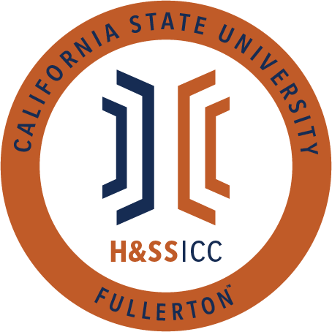

February 19, 2020 11:00 A.M.
Zoom

Meeting called by:
Bernard Perone, Vice-Chair/Treasurer
Type of meeting:
Regular
Attendees:
Council Representatives, Executive Officers, General Public
Agenda Topics:

- Call to Order / Roll Call-11:00 AM
- Approval of Minutes
  - AAEE motions to approve the minutes and LSSA seconds
- Approval of Agenda
  - AAEE motions to approve the agenda and AKD seconds
- Public Speakers
This is a time where members of the public may address the humanities and social sciences council on any item appearing on this agenda or matters impacting students.
5. Budget
    - 8074 – Contracts, Fees and Rentals: $31,335
    - 8077 – Travel: $18,526
6. Reports
- Chair – N/A
- Vice-Chair / Treasurer – Bernard Perone
  - Tonya Somesh, the current Social Justice Facilitator, has been selected as the new chair! Next Friday will be her first meeting.
  - If you plan to submit a proposal, please submit all paperwork by the 10 AM Monday deadline. Bernard is willing to review packets over the weekend to ensure all documents are ready for the Monday deadline so please reach out to him.
- Director of Administration – Savannah Arana
  - Thank you, everyone, for being here this week! Attendance is super important, and I appreciate it when everyone attends this meeting.
  - Nothing to report, so I will yield.
- Director of Public Relations – Jennifer López
  - The HSS ICC Instagram page finally has more than 600 followers! Thank you all for following us, and please continue to promote our page to your fellow students @csufhssicc
- Social Justice Facilitator – Tonya Somesh
  - I am looking forward to being the new chair and serving the council!
  - Nothing to report, so I will yield.
- Advisor – Dr. Connie Moreno Yamashiro, Assistant Dean
  - The FAFSA and CDA priority deadline is on March 2nd. That is coming very soon, and please prepare for that. Fliers will be posted on GroupMe with more information about the deadline. The Financial Aid office is also hosting workshops to help those who may have questions about forms. All information will be posted on GroupMe.
  - HSS scholarships are due soon! You can apply for scholarships directly related to your major or general ones for all H&SS students. Apply for as many as you can.
- Graduate Assistant – Shanice Watson
  - New clubs/clubs that just joined the HSS ICC this semester will be hearing from Shanice soon. She will need their club socials to add to the HSS website. The deadline to add is the 24th.
- ASI Liaisons – Erick Murillo and Maria Linares
  - N/A
7. HSS Week Committees (April 5th- April 9th, 2021)
- HSS Week club event submission http://fullerton.qualtrics.com/jfe/form/SV_6fXB0mfSw7gu8Mm Club event due by 11am on Feb. 26 (one submission per club)
- Today is the symposium submission deadline at 11:59 PM. This is an excellent opportunity for people who want to share their research.
8. Old Business
9. New Business
AKD motions to open line item A of new business and AAEE seconds
- Abled Advocators is requesting $100.00 from line item 8074. The club will be hosting an event celebrating Black History Month on 2/22 at 7:00 PM via Zoom. Funds will be used at this event in the form of four $25 gift cards from Amazon (2) and Target (2). Cards will be given at random to attendants.
  - 21 out of 22 approve/ Motion is passed
ASA motions to open line item B of new business and TESOL Club seconds
- The Anthropology Students’ Association is requesting $1000.00 from line item 8074. Anthropology Students’ Association (ASA) will be collaborating on a webinar along with Titan Archaeology Club (TAC) and ETA Chapter Lambda Alpha Anthropology Honor Society on Friday, February 26, 2021, from 5 – 7:45 pm, via Zoom. Funds will be given in the form of two $500 honorariums to guest speakers Michael Hayes and Desiree Martinez.
  - 21 out of 22 approve/ Motion is passed
TESOL Club motions to open line item C of new business and AAEE seconds
- TESOL Club is requesting $50.00 from line item 8074. TESOL Club will be hosting a New Member Orientation meeting via Zoom on Friday, February 26, 2021, from 4:00 to 5:00. This event is open to all students. Funds will be used towards 2 Amazon gift cards at $25.00 each. Participants will have the chance to win cards by playing games at the event.
  - 20 out of 22 approve/ Motion is passed
10. Next Week’s Agenda
- TAC would like to be added to next week's agenda for line item 8077
- ASSA would like to be added to next week's agenda for line item 8074
- PAGSOCA would like to be added to next week's agenda for line item 8074
- Rebound Scholars would like to be added to next week's agenda for line item 8074
11. Announcements
- AKD will be hosting a grad student panel this Tuesday at 4:15 PM. It will feature current grad students and their experience in the pandemic. The flier will be posted on GroupMe.
- ASSA is hosting a symposium during HSS week, and proposals are due on February 26th. More information will be posted on GroupMe.
- We have a lot of money in line item 8074, so please use the funds. The money is for students, and we would love to give it out to the students.
12. Adjournment-11:47 AM

