CSUF College of Humanities & Social Sciences
Inter-Club Council Meeting
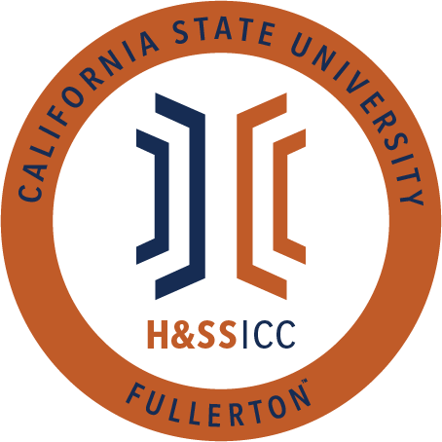

September 6rd, 2019 11:00 A.M.
TSU Legislative Chambers

Meeting called by:
Jacqueline Montero, Chair

Type of meeting:
Regular

Attendees:
Council Representatives, Executive Officers, General Public

Agenda Topics:

- Call to Order / Roll Call
- Approval of Minutes
- Approval of Agenda
- Public Speakers
- Budget
  - 8074 – Contracts, Fees and Rentals: $ 16,000
  - 8077 – Travel: $ 9,000
- Reports
- Chair – Jacqueline Montero
  - Introductions
  - Reregistration
    - Registration is a hard deadline.
- Vice Chair – Ginny Oshiro
  - Requesting Funds
- Director of Administration – Gabriella Cuna
  - Ice Breaker
- Director of Public Relations – Leslie Rodriguez
- Social Justice Facilitator – Valarie Segovia
  - Public Service Social impact internship and career fair Oct 3, 2019 3-6 in pavilions will be hosting an event that day. One of the Departments coming is the US Customs and Border Protection Services. Please let your club and orgs know. This could be triggering for some communities on campus. They’re legally allowed to be at the event, but i am working alongside our ASI BOD (Maria) to make sure that those communities afraid are/will be protected that day. I will also be meeting with our Chief Inclusion and Diversity Officer (CIDO) Monday to see how we can all ensure the safety of our undocumented community. I am hoping the CIDO will agree and help us keep our students safe. If I get any more information, I will continue to let the ICC know. If anyone is worried or would like to speak more on the topic please reach out and contact me by email to set up a time or come to my office hours.

- Housing Liaison –
- Advisor – Dr. Connie Moreno Yamashiro, Assistant Dean
  - About the HSS ICC and my role as the advisor
  - AAHHE
  - DSS Programs for fall
  - Wellness Workshops
  - Career Specialist Drop-in Hours
  - HSS Fall Welcome - Tuesday, September 10 from 11am-1:30pm in front of Humanities Quad

- Graduate Assistant – Miguel Quirarte
  - Career Specialist Melody Lim’s Drop-in Hours
  - Coffee with Cops
  - The Face of HSS Banner
  - Daily Titan back in session
  - HSS Fall Welcome
  - “Ye” Pronoun

- ASI Liaisons – Maria Linares and Melanie Therrien
  - ASI Scholarships
  - All Day ASI, September 12th
  - ASI Town Hall of the Year: Wednesday, 10/2 from 11am-12:30 pm
  - Social Justice Equity Committee: First meeting September 18th from 2:30 pm to 3:30 pm. After that every other Wednesday

- H&SS Week Committees
- Old Business

- New Business
- Next Week’s Agenda
- Announcements
- Adjournment

