CSUF College of Humanities & Social Sciences
Inter-Club Council Meeting
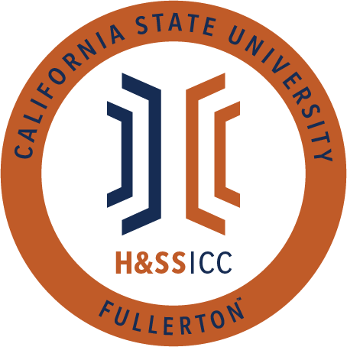

November 13, 2020 11:00 A.M.
Zoom

Meeting called by:
Halima Baba, Chair

Type of meeting:
Regular

Attendees:
Council Representatives, Executive Officers, General Public

Agenda Topics:

- Call to Order / Roll Call-11:03 AM
  - LASSA is marked as absent from the meeting
- Approval of Minutes
  - ASA motions to approve the minutes and AAEE seconds
- Approval of Agenda
  - ASA motions to approve the agenda and SIRE seconds
- Public Speakers
This is a time where members of the public may address the humanities and social sciences council on any item appearing on this agenda or matters impacting students.
5. Budget
  - 8074 – Contracts, Fees and Rentals: $33,060.00
  - 8077 – Travel: $19,181.00
6. Reports
- Chair – Halima Baba
  - Nothing to report, so I will yield
- Vice-Chair / Treasurer – Lila Marlene Rodriguez
  - Message from the Dir. of Leader and Program Development: We will continue to fund virtual conferences only. Furthermore, when submitting a proposal for a conference, there must be proof the event will be virtual when submitting a receipt for reimbursements. Funding for in-person travel is suspended.
  - For 8074: Gift cards need to be delivered digitally and cannot be given in person. We will not fund otherwise.
  - The process of gift cards has changed. Moving forward, we will no longer be using a physical form but instead this link: https://asicsuf.wufoo.com/forms/executive-senate-gift-card-form/
  - Use this link only!
  - Hunger and Homeless Week is coming up soon, so be on the look out for more information.
- Director of Administration – Savannah Arana
- Director of Public Relations – Jennifer López
  - Nothing to report, so I will yield
- Social Justice Facilitator – Tonya Somesh
  - Nothing to report, so I will yield
- Advisor – Dr. Connie Moreno Yamashiro, Assistant Dean
  - Use the new online gift card form. The Word form will no longer be accepted!
  - Hunger and Homelessness Week is coming up soon, and the flier for this week will be shared on GroupMe. This event will cover information about basic needs, EBT application, and other useful resources for students.
  - If you plan on hosting an event at the end of November, please remember in 2 weeks is Fall break, and you need to submit your proposals ASAP to avoid any issues.
  - There will be an event today called Breaking Barriers with JJ Soria, who is a Netflix actor. The flier will be posted on GroupMe if anyone is interested.
- Graduate Assistant – Shanice Watson
- ASI Liaisons – Erick Murillo and Maria Linares
  - Erick Murillo
    - Not much to report for today but please be aware of some news coming from ASI in the coming weeks.
  - Maria Linares
    - Academic Senate meetings take place on Thursdays at 11:30 AM. The Academic Senate speaks on behalf of the university community, and Maria will post a link on GroupMe with dates for people interested in going.
    - Ethnic Studies committee is still planning what the next few weeks will look like, so please talk to your ASI Chief and Inclusion Diversity Officer if you have any questions. Their email will be posted on GroupMe.
    - Cal State Student Association southern region will be hosting an event on 11/16 from 5:30 to 7 PM virtually. They will teach about student advocacy and the legislative process. There will also be an opportunity to chat with many core members from other CSU southern campuses. Link to the event will be posted on GroupMe.
7. HSS Week Committees (April 5th- April 9th, 2021)
8. Old Business
Geography Club motions to open line item A of old business and CJSA seconds
- Club Presentations
- The Linguistics Students Association
- The Teaching English to Speakers of Other Languages Club of California State University Fullerton (TESOL)
9. New Business
Philosophy Club motions to open line item A of new business and SIRE seconds
- Vote: PDSA is requesting $175.00 from line item 8074. PDSA will use the money to buy seven Amazon gift cards priced at $25.00 each for their Bingo and Skribble Social on Wednesday, November 18, 2020, online via Zoom. Gift cards will be awarded randomly to the social’s attendees.
  - 21 out of 23 approve/ Motion is passed
LSA motions to open line item B of new business and Geography Club seconds
- Discussion: Club Presentations
- Student Association for Asian American Studies (SAAAS)
- Society for Interdisciplinary Research in Evolution (SIRE)
10. Next Week’s Agenda
- PDSA would like to be added to next week's agenda for line item 8074
- SIRE would like to be added to next week's agenda for line item 8074
- PAGSOCA would like to be added to next week's agenda for line item 8074
11. Announcements
- At 1:00 PM today, Philosophy Club is continuing their colloquium series. The link will be posted on GroupMe.
- AKD will be hosting an event on Tuesday, 11/17, at 4:15 PM. A graduate student from the Sociology department named Peter Cow will be presenting and discussing his white supremacy research.
12. Adjournment-12:07 PM

