WHY CHOOSE AMERICAN STUDIES?

What will I learn as an American Studies major?
- You’ll learn about America’s culture in the past and present, including its history, ideas, and popular media.
- You’ll gain an understanding of the culture we live in, and how it got to be the way it is today.
- You’ll learn about the immense diversity within American culture, including its ethnic, racial, gender, and regional differences.
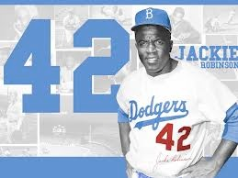
- You’ll belong to a community of engaged students and excellent faculty who share interests and ideas and who work together.
- You’ll be part of an academic department where faculty know you and can advise you personally.
- You’ll become a much better writer, reader, and interpreter of evidence.

What can I do with my American Studies degree?
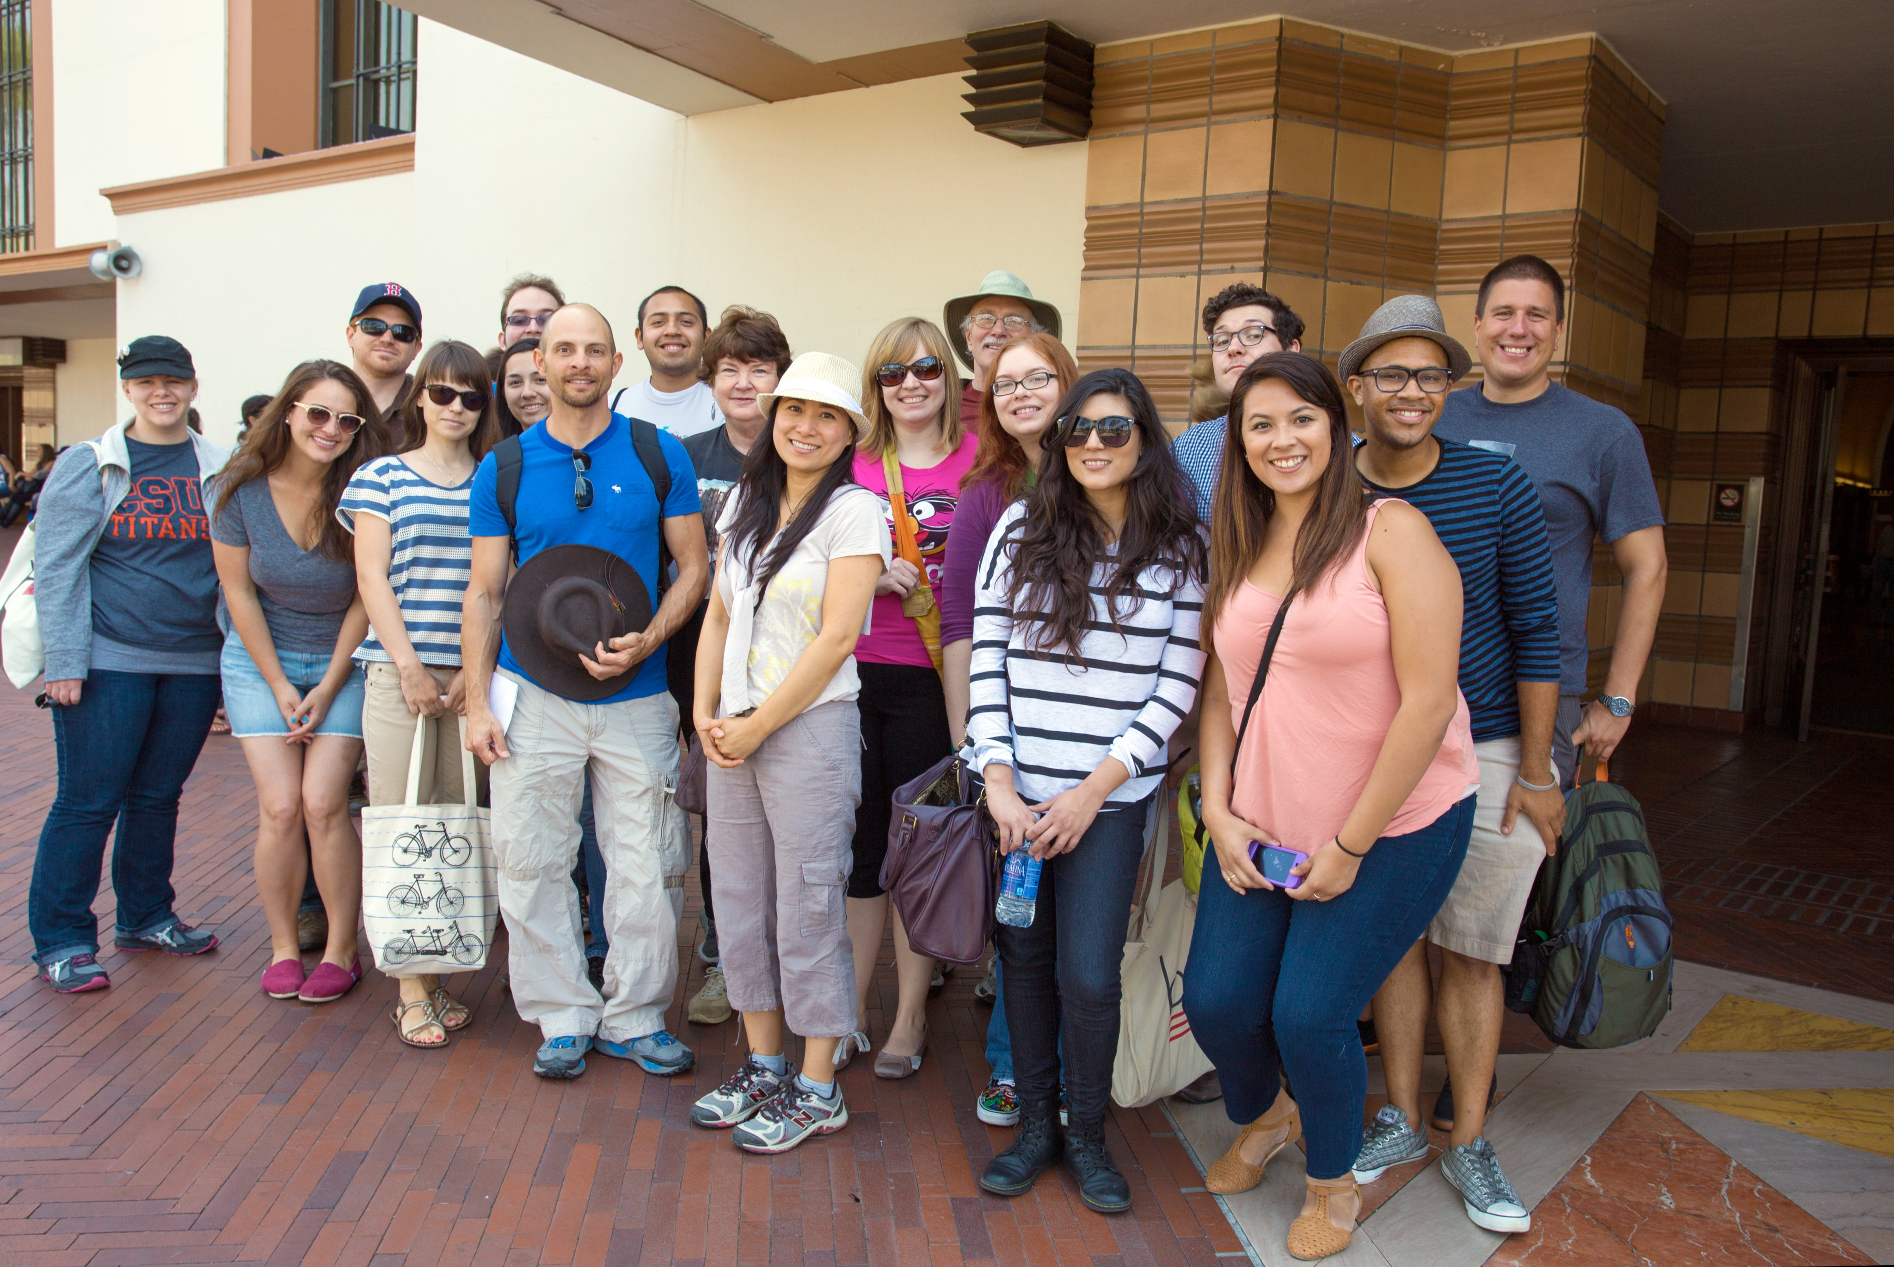
- Some majors earn a “single subject credential” to become social studies or history teachers in middle schools or high schools.
- Some later earn an M.A. or Ph.D. and then teach in community colleges or universities.
- An AMST degree is excellent preparation for law school. It is also an excellent double major with a Comm degree (especially in Journalism, Radio, TV, Film, or Public Relations) or with History, Sociology, English, Ethnic Studies, Women’s Studies, or Political Science.
- Recent majors have found careers in business, public relations, nonprofit organizations, government agencies, museums, and entertainment.
- You’ll learn basic skills to help prepare you for a future in which the average worker will change careers about three times.

What do I need to take to major in American Studies?
- You need 4 required classes (AMST 201, 301, 350, and 401T).
- You also need 8 electives, some of which can be taken in related fields (like Comm, History, English, Sociology, Women’s Studies, Ethnic Studies, or others).
- You need to speak to an AMST faculty member.
- You can also become a double major or you can minor in AMST.

FOR MORE INFORMATION, CONTACT:
Professor Terri Snyder, Chair (snyder@fullerton.edu)
or visit our website.

