# Lab 10: Torque

Experiment for Physics 211 and 225 Lab at CSUF

## What You Need To Know:

### Angular Systems

Every lab up to this point has dealt with objects moving in the linear system. In other words, objects moving in a straight line. Now we are going to deal with the angular system in which objects *rotate*. Every idea in the linear system will have an analogous idea in the angular system. For example, in the linear system we have velocity (which we now specify as *linear* velocity). Linear velocity tells you how far an object travels in a straight line every second (in units of … m/s). In the angular system we have *angular* velocity which tells you how many times an object rotates every second (in units of … revolutions/s). There are many other concepts we could discuss but today’s lab is just going to focus on one of these and that is *torque*.

F

(a)

F

F

(b)

Figure 1 – Forces acting on an object.

### Force and Newton’s 2nd Law

Before we get to torque, let’s jump back a bit and review some ideas in the linear system. You should know by now that a *force* is a push or a pull on an object. More specifically, if you apply a *single* force, F, to an object it will move *in a straight line*. **See** Figure 1(a). According to Newton’s 2nd Law, (ΣF = ma, *net force* equals *mass* times *acceleration*) the object *has* to accelerate. This is so because if there is *only one* force acting on an object then there *must* be a net force and therefore an acceleration.

If there are *two* forces acting on an object then the object might or might not accelerate. If the two forces are *equal* but pointing in *opposite directions* then they cancel out and the *net force is zero* and the object will *not* accelerate. **See** Figure 1(b)**.**

### Torque

Now let’s look at the same ideas but in the angular system. The analogous idea of force in the angular system is called *torque*. A torque is a “force” that makes an object want to *rotate*. Think of it as a rotational force. The equation for torque is written as …

$$τ=rF$$

$τ$ is the torque on an object (in Newton-meters, N·m)

$F$ is the force acting on an object (in Newtons, N)

$r$ is a perpendicular distance [explained below] (in meters, m)

Equation 1 –

Torque

Many people think that, ***r***, stands for “radius” but that is not always the case. This can lead to much confusion on torques. It is much better to think of, ***r,*** as the distance from a chosen reference point to the point at which the force, ***F,*** is acting. (That’s how it’s defined anyway.) Let’s say you have a pulley with a rope wrapped around it. You pull on the rope which gives the rope a tension, **T**.  **See** Figure 2**.** In this case the chosen reference point is the center of the pulley. It was chosen there because that is the point at which the pulley is rotating. (More on this later.) Notice how the distance, ***r***, is shown; from the reference point to where the tension is acting. (And yes, in this case that distance *does* turn out to be the radius of the pulley.)

Another thing you have to remember is that when you plug in for ***F*** and ***r*** they have to be perpendicular to each other. **See** Figure 2**.** If they are not perpendicular then you have to either find a component of ***F*** that is perpendicular to ***r*** or vice versa. In this lab we will only deal with ***F***’s and ***r***’s that are already perpendicular. So, this idea will be left up to your instructor in your lecture to delve into.

Figure 2 – Rope acting on a pulley

T

r

### Net Torque

The equation for Newton’s 2nd Law in the angular system is very similar in form to the one for the linear system.

$$Στ=Iα$$

$Στ$ is the net torque on an object (in Newton-meters, N·m)

$I$ is the moment of inertia on an object (in kg·m2)

$α$ is angular acceleration of an object (in radians/s2)

Equation 2 –

Newton’s Second law in Rotation

All of the variables are analogous to each other; force and torque, mass and moment of inertia, and linear acceleration and angular acceleration. You simply switch out one for the other.

The ideas work out the same as well. In Figure 2 there is one torque acting on the system (in this case, τ = Tr). If you apply a *single* torque to an object it will *rotate*, and according to Newton’s 2nd Law for the angular system, the object *has* to *angularly* accelerate. This is so because if there is *only one* torque acting on an object then there *must* be a net torque and therefore an angular acceleration. This is the same idea discussed for the linear system on the previous page.

If there are *two* torques acting on an object then the object might or might not angularly accelerate. If the two torques are *equal* but pointing in *opposite directions* then they cancel out and the *net torque is zero* and the object will *not* accelerate. **See** Figure 3**.**  (Again, same idea as before.)

T

T

r

r

**+**

Figure 3 – Torques acting on an object.

Just like in the linear system in which we have to choose a linear direction as positive, we also have to choose a rotational direction as positive. That will be either clockwise or counterclockwise. In Figure 3 let’s call clockwise positive (as shown). Now we can say that the tension in the rope on the right is causing a torque in the clockwise direction (positive) and therefore trying to make the pulley rotate that way. The tension in the rope on the left is causing a torque in the counterclockwise direction (negative) and therefore trying to make the pulley rotate that way. These two torques cancel each other out and the pulley does not rotate at all.

### Center Of Mass

In the past, when drawing free-body diagrams, you probably have been just arbitrarily drawing in a weight vector at any particular location. In dealing with torque we can see that the location of the force is important. So, now you have to be more careful in which place you draw your weight vector. You should be drawing it at the *center of mass* of your object.

The center of mass of an object is defined as the average location of the total mass of the object. *Huh?* Ok … if you took the entire mass of your object and compressed it down to a *single point* your object would still act as though the mass were spread out before you compressed it. That point is the center of mass. *Double huh?*  Let’s discuss an example …

Let’s say we have a meter stick. Its mass is uniformly distributed throughout itself so we would say that its center of mass is at the exact center of the meter stick. This is where we would place the weight vector of the object. **See** Figure 4a**.** Now, let’s say that we drill a hole on the right end of the meter stick. The mass of the stick is no longer distributed uniformly across the stick because of the hole. This would cause the center of mass of the stick to be shifted to the left. **See** Figure 4b**.**



W

W

Hole

Figure 4 – Center of mass for meter sticks.

(a)

(b)

In today’s lab you will be dealing with a meter stick whose mass is not uniformly distributed. They have been altered specifically for this lab. So, one of the first things that you will have to do is find the center of mass of the meter stick.

### The Equipment

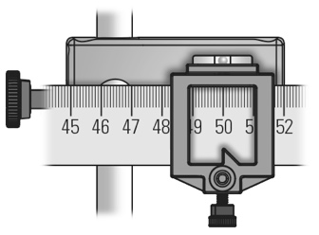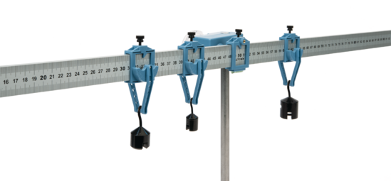

Measuring Edge

Clamp

Pivot Clamp at the Fulcrum

Figure 5 – Torque Equipment

Hooked Mass

The equipment for this experiment is shown in Figure 5. Note each Clamp has a Measuring Edge to get the position needed. Your equipment should have started disassembled on the desk.

Also observe the Hooked Masses have a bar on the bottom for hanging additional masses on them. You can adjust the height of the pivot point as needed for longer chains.

There is also a force probe attached higher on the rod but you won’t need that until Part 7.

## What You Need To Do:

NOTE: In Appendix A there is a chart that you can use to fill in your data for some parts of this lab. Detach it and use it as the first page of your lab report. You can answer questions on this sheet too. Use your own loose-leaf paper if you need more room for answers and calculations.

### Part 1 - Center Of Mass

In order to find all the torques on an object, you have to include the torque due to the weight of the object. Depending on the reference point that you choose, the weight of the object might have a torque.

The location at which the weight of the object acts is at the center of mass of the object. So, the first thing we are going to do is find the center of mass of the meter stick.

1. Locate the Aluminum meter stick and the Pivot Clamp that attached to the rotary motion sensor at the Fulcrum, see Figure 5. Before you begin get the mass of that meter stick using a digital scale, unless your instructor decides to provide it for you.
2. Carefully insert the meter stick into that clamp.
3. Slide the meter stick into the Pivot Clamp until it gets to about the center of the stick.
4. Release the meter stick and observe its motion. Adjust the location of the clamp back and forth until the stick remains relatively horizontal.
5. Once the stick is decently balanced, record the location of the Pivot Clamp. This is the location of the center of mass of the meter stick. You will be using the value throughout the lab.

Notice that, before the clamp was at the center of mass, the stick rotated about the fulcrum. That means that there must have been a net torque on the stick. The weight of the stick was acting at a distance, ***r***, away from the fulcrum and thus was causing a net torque (i.e. the stick rotated). Once you placed the clamp right at the center of mass, the weight of the stick was acting *at the fulcrum*. That means that ***r*** = 0 and there would not be a torque (i.e. the stick remained horizontal).

### Part 2 - Single Torque

Leave the clamp at the center of mass of the stick and keep this setup.

1. While holding the meter stick horizontal, slide a clamp with a swinging hanger to about the 80 cm mark.
2. Release the meter stick. Describe what happens and also explain why in terms of what has been discussed so far.
3. While holding the meter stick horizontal, remove the clamp at 80 cm and place it on the other side of the stick at 20 cm.
4. Release the meter stick. Describe what happens and also explain why in terms of what has been discussed so far.

For each of the instances above, in adding the clamp to one side of the stick we added a net torque to the system. This caused the stick to rotate. One way caused a clockwise torque, the other way caused a counterclockwise torque.

### Part 3 - Net Torque

So far there has only been one torque acting on the ruler. Now you will be dealing with a system that has multiple torques acting on it.

|  |  |  |  |  |  |  |  |  |  |  |  |  |  |  |  |
| --- | --- | --- | --- | --- | --- | --- | --- | --- | --- | --- | --- | --- | --- | --- | --- |
| **P a r t** | **Counterclockwise Torques** | | | | | | | **Clockwise Torques** | | | | | | | **% Diff.** |
| **1st Torque** | | | **2nd Torque** | | | **Total Torque** | **1st Torque** | | | **2nd Torque** | | | **Total Torque** |
| **F** | **r** | **τ** | **F** | **r** | **τ** | **F** | **r** | **τ** | **F** | **r** | **τ** |
| **3** |  |  |  |  |  |  |  |  |  |  |  |  |  |  |  |
| **4** |  |  |  |  |  |  |  |  |  |  |  |  |  |  |  |
| **5** |  |  |  |  |  |  |  |  |  |  |  |  |  |  |  |
| **6** |  |  |  |  |  |  |  |  |  |  |  |  |  |  |  |

Table 1 – Parts 3 to 6 Data

1. Include Table 1 in your lab report. You’ll find a larger copy in Appendix A – Table 1 for printing or filling digitally.
2. Take note of the mass of your clamps, for this experiment you can use the value written on the clamp, or you can weigh it with a digital scale for added precision.
3. While the meter stick is balanced at its center of mass, place one clamp at 20 cm on the stick.
4. Holding the meter stick horizontal, take the other clamp and slide it on the stick from the right-hand side until the stick remains horizontal when you let it go.

Question 1

How many forces are acting on the meter stick? Draw a diagram of the meter stick showing each force vector acting on it. Place each vector in the approximately correct location as well.

Question 2

If the location of the fulcrum is taken as the reference point (this will be the case for the entire lab), how many torques are acting on the meter stick? Why is this number different than the number you wrote for the answer to **Question 1**?

Question 3

In what directions are the torques acting (Counterclockwise or Clockwise)?

Question 4

What is the net torque acting on the meter stick? How do you know this by looking at the meter stick?

1. Calculate the *weight* of each clamp. (Make sure you are using units of kilograms for *mass*.) Put these values in the chart in the row labeled **Part 3**, under the columns labeled as ***F***.

NOTE: In the chart there are extra columns for torques that you might not use depending on which part of the lab you are working. This is left ambiguous in order for YOU to determine how many torques you have, either clockwise or counterclockwise.

1. Measure the distance, ***r***, (in meters) for each torque. Remember, ***r*** is defined as the distance from your chosen reference point (in this case, the fulcrum) out to where your force is acting. Place these values in the chart.
2. Calculate the torques, ***τ***, and put these values in the chart. Also, put these values in for the total torques since there is only one torque per side. Calculate a percent difference between these totals. If you got a value greater that 5% then you are doing something wrong. Go back and check your data and if you can’t find the issue then check with your instructor before you continue.

### Part 4 - C of M as Torque

For this section you will be moving the fulcrum away from the center of mass. This will cause the weight of the meter stick to have a torque.

1. If you don’t have it yet measure the mass of the meter stick WITHOUT the fulcrum clamp on it.
2. Reinsert the meter stick so that the pivot clamp is at the 60 cm mark.
3. Put a clamp with a 100g hooked mass on the meter stick and adjust it until the meter stick is balanced. (You’ll have to figure out which side to put it on.)

Question 5

How did you know where to place the hanger to balance the stick? Explain in detail using torques.

1. Draw a diagram of the meter stick showing each force vector acting on it. Place each vector in the approximately correct location as well. Describe the torques acting on the stick.
2. Calculate the weights that are causing the torques on the stick and place these values in the appropriate places in the row labeled **Part 4**. Make sure you now include the 100 g additional hooked mass.
3. Measure the distance, ***r***, for each torque. Place these values in the chart.

Calculate your torques and total torque. Calculate a percent difference between your total torque values. If you got a value greater that 5% then you are doing something wrong. Go back and check your data and if you can’t find the issue then check with your instructor before you continue.

### Part 5 - Multiple Torques on a Side

Remove the clamp currently on the meter stick. Keep the fulcrum at 60 cm.

1. Add 200 g hooked mass to one of the clamps and place it at 90 cm.
2. Add a 100 g hooked mass to the other clamp and place it on the meter stick to balance the system.
3. Draw a diagram of the meter stick showing each force vector acting on it. Place each vector in the approximately correct location as well. Describe the torques acting on the stick.
4. Calculate the weights for each torque acting on the stick and place these values in the appropriate places in the row labeled **Part 5**.
5. Measure the distance, ***r***, for each torque. Place these values in the chart.
6. Calculate your torques and total torque. Calculate a percent difference between your total torque values. If you got a value greater that 5% then you are doing something wrong. Go back and check your data and if you can’t find the issue then check with your instructor before you continue.

### Part 6 - Mixin’ It Up

Remove all hanger assemblies.

1. Place the fulcrum at 75 cm.
2. Take both clamps and put one on each side of the meter stick, then slide them all the way in so that they’re touching the pivot clamp.
3. Balance the meter stick without removing either clamp by hanging additional masses and moving each clamps location as needed.
4. Draw a diagram of the meter stick showing each force vector acting on it (Don’t forget the clamp itself has mass. Place each vector in the approximately correct location as well. Describe the torques acting on the stick.
5. Appropriately fill out the row labeled **Part 6** in your chart as you have been.

### Part 7 – Calculating Tension

So far, the only torques you’ve been dealing with have been caused by weights. Now, a tension is going to cause a torque.

1. Open the file **FORCE PROBE**. Click CONNECT on the extra window that opens. Zero the probe with nothing hanging from the force sensor by pressing the “Set Zero Point” button.
2. Place the pivot clamp/fulcrum at 20 cm.
3. On the table there is a piece of string with one end tied in a big loop and the other in a small loop. Slide the big loop around the ruler until it is at 40 cm. Have the small loop hang on the hook on the Force Sensor which is hanging from a stand. Adjust the Force Sensor until the meter stick is horizontal by changing its position on the bar and its height. **See** Figure 6**.**

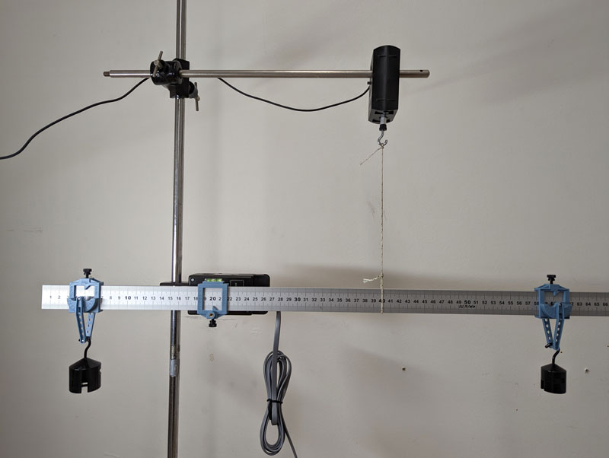

Figure 6 – Part 7 Setup

1. Take one clamp and place it at 5 cm. Hang a 200 g hooked mass on the clamp hanger.
2. Take the other clamp and place it at 60 cm. Hang a 100 g hooked mass on the clamp hanger.
3. Draw a diagram of the meter stick showing each force vector acting on it. Place each vector in the approximately correct location as well. Describe the torques acting on the stick.
4. So far you have been verifying that the clockwise torques equal the counterclockwise torques. Based on this idea, make an equation that will allow you to calculate the tension in the string. Make sure you use units of kilograms and meters so that you will get Newtons for tension. Calculate the tension.
5. In the LoggerPro Force Probe file you opened there will be a small window that tells you the tension in the string. Record this value.
6. Calculate a percent difference between the computer value and your calculated value. If you got a value greater that 10% then you are likely doing something wrong. Go back and check your data and if you can’t find the issue then check with your instructor before you continue.
7. Reset the lab to how it was when you entered:
   1. Remove the string from the meter stick and hook it on just the force probe.
   2. Remove all clamps from the meter stick.
   3. Return all hooked masses to the mold.
   4. Remove the meter stick from the pivot clamp and place it on the table.
8. Thank you!

## What You Need To Turn In:

Write your lab report using the next page as the front sheet. Use your own paper for additional pages. Make sure you show your work for each section in the corresponding section in your report. Answer all of the questions.

© Spring 2013 by Michael J. Dubuque - rev 2023

## Appendix A – Table 1

Names:

|  |  |  |  |  |  |  |  |  |  |  |  |  |  |  |  |
| --- | --- | --- | --- | --- | --- | --- | --- | --- | --- | --- | --- | --- | --- | --- | --- |
| **P a r t** | **Counterclockwise Torques** | | | | | | | **Clockwise Torques** | | | | | | | **% Diff.** |
| **1st Torque** | | | **2nd Torque** | | | **Total Torque** | **1st Torque** | | | **2nd Torque** | | | **Total Torque** |
| **F** | **r** | **τ** | **F** | **r** | **τ** | **F** | **r** | **τ** | **F** | **r** | **τ** |
| **3** |  |  |  |  |  |  |  |  |  |  |  |  |  |  |  |
| **4** |  |  |  |  |  |  |  |  |  |  |  |  |  |  |  |
| **5** |  |  |  |  |  |  |  |  |  |  |  |  |  |  |  |
| **6** |  |  |  |  |  |  |  |  |  |  |  |  |  |  |  |