# 225L Acceleration of Gravity and Measurement Statistics

## What You Need to Know:

### Introduction:

The most important and readily available source of acceleration has been gravity, and in particular, free fall. One of the problems with a direct measurement of the acceleration of gravity is its relatively large acceleration, which made accurate vertical position vs. time measurements over short falls difficult before the advent of modern electronic measurement systems.

In the present experiment, we will determine the acceleration of gravity of a freely falling object and use a photogate to measure the very short time intervals between equally spaced[1], dark bands on a clear plastic rectangle called a Picket Fence (see Figure 1). When the Picket Fence passes through a photogate, the device notes when the infrared beam of the photogate is blocked by a dark band and measures the time elapsed between successive “blocked” states. The software uses these times and the known distance from the leading edge of a dark band to the next to determine the velocity of the picket fence as it falls through the photogate. Due to the acceleration of gravity and resulting increase in speed, the intervals between the on and off times get shorter and shorter as the picket fence falls thru the photogate light beam.

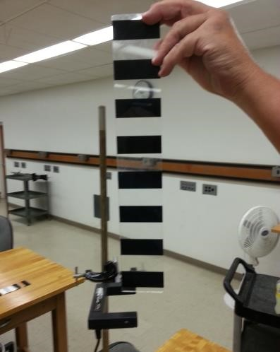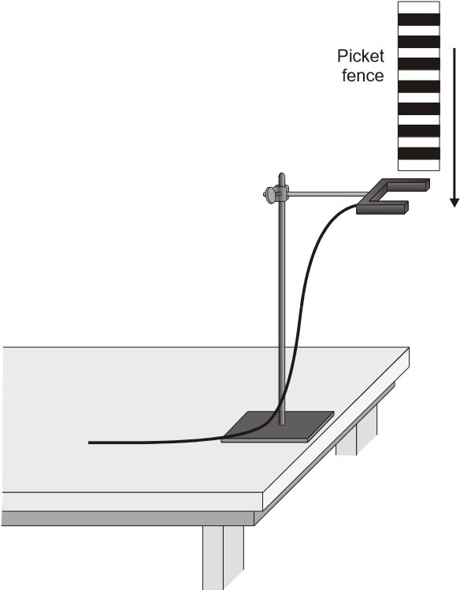

Figure 1: Diagram and photo of picket fence and photogate apparatus. Be sure to insert back edge of picket fence far enough into the photogate to break the optical beam and to drop it vertically.

### Summary of the Experiment:

This lab experiment will be done in three parts

Part1:

Setup and test the Logger Pro Software to display position, velocity, and acceleration and corresponding fits to the data with the fit parameters displayed on screen as shown in *Figure 2*.

Part 2:

Obtain a “good” value of g for a single run (out of 3-5 or so trials) and compare the g and v0 values obtained from the position, velocity, and acceleration plots using fits to the data.

Part 3:

The main event. Generate two histograms similar to the example in *Figure 4*, one for g and one for v0 (you will have to experiment with manually adjusting the number of bins to get a good histogram).

## What You Need to Do:

### Part 1: Initial software setup and hardware test

Start by familiarizing yourself with the software and making sure everything is working and displaying properly. Do the following:

1. Open the Logger Pro software file called: “225-FreeFall.cmbl”. It should look similar to *Figure 2* and may or may not have data displayed in it already. There should be inset boxes for the data fit parameters that will fill in after data is taken.
2. Click the green collect data button at the top of the Logger Pro menu bar. Note that data is not collected until the picket fence breaks the beam. You can wait as long as you want after the collect button is pressed before you drop the picket fence through it.
3. Test the data collection by dropping the picket fence through the beam. The fit parameter values and graph should update each time you click the collect button and drop the picket fence through the photo gate timer.
4. 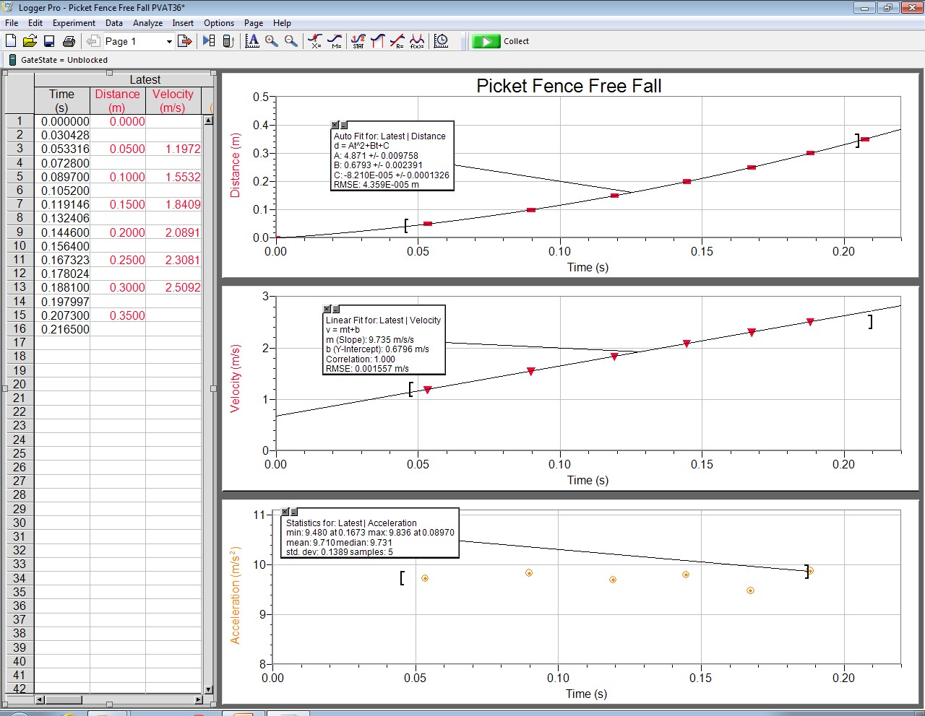Make sure the position, velocity, and acceleration scales display the data completely. You can adjust the ranges of each graph.

Figure 2: Example data shown, note all axes and fit ranges are adjustable.

**Part 2: Obtain a good value of g and compare.**

This is a very precise experiment. Start by making sure you can get a good data point by following these steps.

1. Practice dropping the picket fence through the photogate a few times without it touching the side (when that happens, the contact friction slightly slows down the picket fence, and the value for g is too low). The picket fence is best dropped when held from the top center with 2 fingers. Holding it off to one side is a source of error due to the resulting tilt and the picket fence passing through the timer at an angle

Question 1:

Explain in your own words why the tilt will cause an error. Drawing a sketch may help explain.

1. Take data on a drop. Looking at the velocity graph, if the value for g(slope) is in the “good” range[2] of record that data and take a screenshot of all 3 graphs showing the fit lines and the values of the fit parameters. Identify the fit parameters with g and v0 for the position and velocity graphs.
2. The FreeFall file should already show a fit line for each graph. If it doesn’t, it should be a quadratic fit for the position, a linear fit for the velocity, and the mean value of the data for the acceleration, as shown in *Figure 3*.

The reason for each fit lies in the kinematic equations, you can compare the fit equations to the two following kinematic equations to find your acceleration $g$, and initial velocity $v_{0}$.

(1)

$$y=\frac{1}{2}gt^{2}+v_{0}t+y_{0}$$

And

(2)

$$v=gt+v_{0}$$

1. Note each fit has an adjustable range, make sure you have properly selected all the data to include.

Figure 3 - Example position, velocity, and acceleration graph screen shot showing the scale setup and the least square fits to the data. Note the fit parameters and their standard deviations in the inset boxes. For this run the velocity vs. time graph gave a value for the slope m = g = 9.73 m/s2. The position vs. time graph gives 2A = g= 9.742 m/s2. The acceleration graph gives a mean value of 9.71 m/s2, but is only based on 5 data points.

1. Calculate the values of g and v0 and their standard deviations from each of the three plots by comparing the fit to the kinematic equations (1), and (2).

|  |  |  |  |
| --- | --- | --- | --- |
| Value From: | Distance Graph Fit | Velocity Graph Fit | Acceleration Graph Statistics |
| $$g$$ |  |  |  |
| $$v_{0}$$ |  |  | X |

Question 2:

Comment on any similarities or differences between the 3 methods. Which do you think is the most accurate and why?

### Part 3: Generate two histograms, one for g and one for v0.

Now it’s time to collect the data:

1. Begin the data-collection program as you did before and drop the picket fence through the photogate.
2. Since you are now investigating the variation in the values of *g* AND v0, you need only record the value of the slope and intercept in your separate data table of the best-fit line to the velocity-time graph for each trial. Reference equation (2).
3. Repeat this process until you have collected 35 values for $g$ and $v_{0}$.

You will need to submit all 35 values to your instructor at the end of lab so be sure they’re recorded as specified by your instructor.

1. Make two histograms using excel or Logger Pro:
   1. Make a Histogram for your g values. Be sure to label graph title and axes.
   2. Make a Histogram for your $v_{0}$ values. Be sure to label graph title and axes.

See the “Making a Histogram:” section at the end of this lab for help on making these histograms if you need it. There is also a sample Logger Pro histogram in that section.

1. Adjust the bin sizes of your histograms to make each a “good” histogram. (6-7 bins is good for this amount of data). See *Figure 4*.

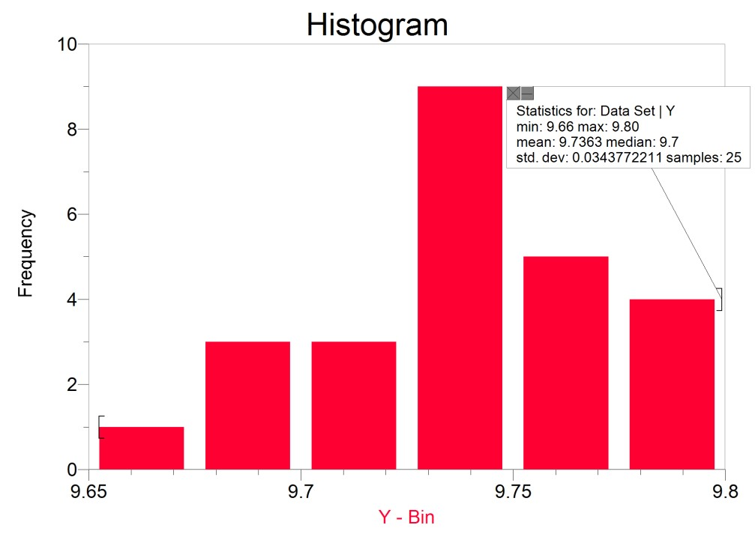

Figure 4: Example Logger Pro histogram of g values for 25 samples with statistics displayed. You should obtain 35 values for g and v0. Note we have selected the bin range and number of bins so as to display the “best looking” histogram (6 or 7 bins usually looks good for this few data points).

1. Determine the average(mean) value of *g* for all 35 trials. You can do this using the =AVERAGE() equation if your data is in excel, or just highlight all your values and take a look at the bottom of the window, excel automatically displays average and count for selected data.
2. Take screenshots of both your g and your v0 histograms and paste into your Word document. Make it large enough that you can draw lines on it.
3. Draw vertical lines indicating the mean, mean plus 2 standard deviations, and mean minus two standard deviations on both the g and v0 histograms. This represents 90% probability that the data lies in that region if one has a gaussian random process.

Question 2:

1. Also calculate the acceleration value for just the first five trials. How does this value compare with the value you obtained for the entire 35 trials?
2. In which average do you have greater confidence? Why?

Question 3:

For your histogram of g, estimate by counting: (Note excel automatically counts when you highlight cells down at the bottom)

1. in what range (minimum to maximum) do the middle 2/3 of your values fall?
2. In what range do roughly 90% of the values closest to your average fall?

Question 4:

One way to report the precision of your values is to take half the difference between the minimum and maximum values and use this result as the uncertainty in the measurement. Determine the uncertainty in this way for each range of values you determined in Step 9.

Question 5:

1. In what place (tenths, hundreds, thousandths) does the uncertainty begin to appear?
2. Is it reasonable to report values in your average beyond the place in which the uncertainty begins to appear? Explain your answer.
3. Round your average value of *g*to the appropriate number of digits and report that value plus the uncertainty.

## What You Need to Turn In:

**Lab Report**:

Your lab report should contain 3 screen shots. 1 similar to *Figure 3*, and 2 similar to *Figure 4* in the Histograms section, (one for the values of g, and one for the values of v0).

It should also have your data table, and any comments, answers to questions and hand written calculations that you perform.

Be sure to write a summary of the results for the experiment at the end as guided by your instructor..

KW 02/15 rev. AG 02/23

## Making a Histogram:

### Excel (2019)

To make a histogram in excel:

1. Enter all your values in one column.
2. Click and drag to highlight all values.
3. Go to the “Insert” tab at the top
4. Click the “Insert Statistic Chart” Button
5. Select Histogram.
6. From there you can add axes titles by clicking the + on the top right of graph
7. You can adjust bin sizes by right clicking the ranges on each axes and selecting “Format Axis…”

### Logger Pro (v3.16.2)

1. Close Logger Pro file. Disconnect the photogate from the interface.
2. Open a blank file (double click the Logger Pro shortcut.)
3. The program should open with a table of X and Y columns.
4. Paste the data into the **Y** column.

Add a histogram by selecting Additional Graphs ► Histogram from the Insert menu at the top.

1. The picket fence is a rectangle 38.8 cm long and 6.5 cm wide. The width of the dark bands and transparent regions is 25mm. The distance from the leading edge of a dark band to the next is 50mm.
2. The local value of g = 9.796 m/s2 for Fullerton. 34°N latitude and elevation of 155+90 ft. = 245 feet, 6th floor. http://www.sensorsone.com/local-gravity-calculator/